****

**greenchurches.ca**

**Ethical meat consumption**

Reflecting on our meat concumption

|  |  |
| --- | --- |
| **Goal** | This activity focuses on the theme of awareness. At the end of this activity, the Christian community will have become aware of the lack of respect for animal welfare in breeding and slaughtering. She will discover what are the impacts and how to react . |
| **duration** | 1 hour and 30 minutes   : 10 minutes for the reception and introduction, 5 minutes to the travel time, 1 hour for the group'sactivities of age and 10 minutes for the return on activity. |
| **Equipment** | General   : a slide show with biblical passages, a projector, a laptop, several photocopies of appendix 4 (family writing), pencils, cardboard , glue and stick.  6 years and under   : Doggies animal farm and a cat and a dog, a Bible, a carton, a marker of the sticker, rope, six chicken accessories, pig or cow print and laminate the meat images in Appendix 2 with some examplesand some modeling clay.  7 to 12 years   : print and laminate pictures of Schedule 2 a copy, thevideo *It's not rocket science -* *F* *ilières meat,* a projector, a laptop andspeakers.  Teenagers and adults   : animators for sharing groups, the DVD *Food Inc.*, projector, laptop, speakers(or a TV and DVD player), Bibles and several copies of Canada's Food Guide (Appendix 3). |
| **Place** **x** **suggested** **s** | The church gatherings and community rooms available for group activities s age. Give priority to outdoor activities, weather permitting. |

**Welcome and introduction** **(10** **minutes)**

Event organizer greets members of the community and asks the following question   : " In your opinion, does the Bible tell us to be vegetarians? "

Take some answers.

Then project the following scriptures   :

1. G e n esis 9 3-4   : " All that moves and lives that will serve you food as already the maturing grass, I give you everything. However you will not eat the flesh with his life, that is, his blood. "

2. L u c 15, 20-24   : " He went to his father. As he was still far away, his father saw him and took pity on him   he ran to throw himself on his neck and covered him with kisses. The son tells him   "Father, I have sinned against heaven and against you. I do not deserve to be called your son anymore ... " But the father says to his servants   : "Quick, bring the most beautiful dress, and dress it up   ; put a ring on his finger, sandals on his feet. Bring the fat calf, kill it, eat and feast, because my son here was dead and he came back to life, he was lost and he is found. " " (The fat calf is killed for a special occasion   : we do not eat the calf everyday).

The organizer therefore concludes by saying   : " The Bible does not require us to be vegetarian, but it tells us to take care of the animals we breed and kill. We will see what are the current conditions of farming and industrial and traditional slaughter. "

As for GMOs, insist on the respect we have for farmers, who by their work feed a lot of people. On the other hand, these breeders are sometimes caught in economic systems that prioritize productivity and profit rather than respect for other creatures.

**Displacement (5 minutes)**

Present the locations where participants will need to go based on their age. Also introduce volunteers who will be with the youth. Then everyone moves to the right place.

**Activities by age group** **(1 hour** **)**

6 years and under

1. Domestic animals

Bring stuffed animals to the farm (children of this age love stuffed animals so much!). The main animals to have   : a cow, a pig and a chicken. Also bring a cat and dog pooch.

*An alternative to doggies*  *: plastic animals or printed and plasticized images.*

Have the children sit down and ask who among them have a dog or cat at home. Give the cat and dog puppy two children to show others how to take care of them (eg flatter the animal, feed it by giving it fresh water every day, clean the litter of the cat , walk the dog outside to do his needs, etc.). The facilitator can ask questions to the children to highlight counterexamples . For example, the facilitator may ask the children if it is appropriate to feed the cat with food, if it is acceptable to clean the bedding every 2 weeks only, etc.Highlighting the fact that it must make p care of our animals and it must meet their need s.

If young people have other pets than the cat or dog , give them time to express how they care for their animals, how they are listening to their needs. The goal is to start from the experience of life, from the daily experience , to then make the transfer with the reality of the animals of the farm.

Ask the children if all animals should be treated well as our pets.

2. The animals on the farm

Ask three children to come forward in turn . Everyone must move and imitate the animal you blow in your ear. The rest of the group must guess which animal it is. The three animals to guess are   : the hen, the pig and the cow. Ask the children, according to them, what is the necessary care to bring to these animals.

According to you, does God want us to take care of animals? Allow time for the children to respond. Open the Bible and read Prov erbes 12, 10 " The righteous knows the needs of his animals . "Write to them this biblical passage on cardboard and display on the wall for it to be shown at the sight of all. We can refer to this passage at other times during the different activities.

Tell them that the hen and the pig need space to move and that the cow needs to handle grass. Unfortunately, not all breeders meet the needs of the chicken, the pig and the cow.

3 . Game of the enclosure

With a rope, draw a rectangle on the ground. Make, according to your imagination, an accessory of chicken, pig or cow (otherwise, in appendix 1 , there are models of masks to print that you can make hold with a stick or thanks to a rope) . Ask two children to come into the rectangle and give them a hen , pig or cow accessory . Ask the others if both animals have space to move in this enclosure. Ask four more children to come into the pen and give them a pet accessory too . Do the six animals have a lot of space in this enclosure? Ask the six children if they felt tight in the pen, if they felt completely comfortable ...

Breeders who care for animals and who respond well to their needs should be encouraged   : this is called responsible drinking. Some producers do not care about animal welfare  What they want is to raise as many animals as possible to make the most money possible.

4. Association game

Print and laminate the images in Appendix 2 in a few copies (depending on the number of teams you want to train). Ask the children to associate the animal with the product (s) we can eat. They place themselves in a team of two.

Make a return on the activity with the children. Tell them that even if we eat pork, chicken, and drink the cow's milk, we have to take care of those animals.

5. Sing *All the animals of the world*

**Refrain:**   
**All the animals of the world**   
**All animals are our friends**   
**From lion to dove**   
**From fox to marmoset**

The bull is not happy   
his wife is cow it's heartbreaking   
The owl sings loudly   
I'm happy my wife is nice

**Refrain**

Although he is the most muscular   
The elephant feels bullied   
Because he has two eyes all black   
But with no defense to see

**Refrain**

I have a happy poodle   
Who likes to be nested   
And a very shy fish   
Who does not like fishing at all

**Refrain**

What is the feast of cats   
I give my tongue to the cat   
You can not find at all?   
Let's see it's mid-August

**Refrain**

Try to offer a drink   
Even in the middle of the desert   
To my friend the zebu   
He will tell you: I drank.

6 . Modeling clay

Invite the children to create a hen, a pig or a cow in plasticine. Then let them play with each other as if all the animals were on the farm. Some children can make a plasticine farmer and he has to take good care of the animals on the farm.

If we see that children are no longer interested in this game, offer to play free games. Otherwise, play with animals made of modeling clay is a free play to allow room for creativity, the imagination of children.

7 to 12 years

1. Where does the meat come from?

As a first step, to activate previous knowledge, ask the young people where the meat is coming from . Separate the group in half. Show images of meat ( Appendix 2 ) and the first team that raises their hand has the right to speak. Record points to know the winning team.

Ex. If we show the image of bacon, it is the first team that mentions the pig that has a point.

2. Video

Watch a video about breeding and slaughtering animals (25 minutes and 59 seconds) .

Title of the video   : *It's not rocket science - Meat sectors* (Video presented by *C'est pas sorcier stream* )

[https://www.youtube.com/watch?v=W7jyXDDSjjw](https://translate.google.com/translate?hl=fr&prev=_t&sl=fr&tl=en&u=https://www.youtube.com/watch%3Fv%3DW7jyXDDSjjw)

Here are some suggestions for questions to ask young people   :

-What did you learn about the operation of intensive farming?

-What did you understand about mad cow disease? (Emphasize that if you take good care of the animals , you take care of the humans too, you have to take care of the animal feed because it has an impact on their health and ours ).

What is the function of hormones injected into animals? (This allows the animals to grow faster and therefore be sold faster, but we do not know exactly the effects of the hormones on us, the consumers.)

-What is the function of antibiotics injected into animals? (This allows animals to grow faster and protect them from disease, but they never kill all the bad bacteria and can cause diseases for humans , which are difficult to treat.)

-In the video, we explain that in France, there are different types of chicken   : standards, conforms, labels, bios and AOCs. What changes from one kind of chicken to another? (Injecting antibiotics or not, what they eat, whether they live in a building or outside, the space allocated to the m 2 per hen and the number of days they live before to be slaughtered.)

-And what kind of chicken would you buy and why?

3. Link with the Christian faith ...

-God does he want respect for animals that he created ? Let the young people express themselves on the subject .

-Does God want the health of the humans he has created? Let the young people express themselves on the subject.

In general, one might conclude by saying that God loves his creation, animals and humans. It's good to keep that in mind when buying meat.

Open the Bible and read Proverbs 12, 10 "The righteous knows the needs of his animals. "

We can read also Luke 13, 15   "   On the Sabbath, do not each one of you leave his ox or donkey to feed him?   "

In conclusion, ask the young people, in the light of their faith, with what they leave today. In other words, what will today's activity change or not about their meat consumption?

Teenagers and adults

Listen to the DVD *Feeders* (Food Inc.) from Scene 2 ( *The Cornucopia* ) up to 27 minutes and 27 seconds (when at Scene 4 the screen goes black , just before seeing the two ladies in the auto). Then, place the DVD at Scene 6 ( *Happiness is in the Meadow* ) for up to 50 minutes and 33 seconds (when the screen turns black). In all, the viewing is almost 30 minutes.

Once the viewing of the documentary is over, discreetly, the teenagers head to another local to share together around the questions.

Since the documentary is long and raises a lot of questions and thoughts, we suggest focusing on small sharing groups. Thus, all will have the time to express themselves and listen to others on the various questions asked.

Here are some ideas to ask   :

-What is my reaction regarding the conditions of industrial chicken farming?

-What is my reaction to getting cow corn to eat because it is cheaper when it is made to eat grass?

- What is my reaction to the fact that because corn is fed to the cow, there is spread of E. coli, contaminating not only the cow , but also the fruit and vegetable fields? and human beings?

-Why comparing intensive and traditional breeding and slaughter, what concerns me?

According to me, what is God's plan for his creation (humans, animals, environment ...)?

We can ask sub-questions to feed this discussion   :

1. Does God want the respect of animals? (These include the passage of Ex ode 23, 12 "Six days you shall do what you have to do, but the seventh day you chômeras, that your ox and your donkey may rest, and the son of thy handmaid and emigrated catch their breath. " Proverbs 12, 10 "The righteous knows the needs of his animals. "And Luc 13, 15   "   On the Sabbath, do not each one of you leave his ox or donkey to feed him?   » )

2. Does God want the health of the humans He created? (One can quote the text of 3 J e n 2 « Dear friend, I wish that you are well in all respects, and that your health is good, that it goes as for your soul which it is well . "and the text of 1 Corinthians 3.16 rinthiens" Do not you know that you are God's temple and that God's Spirit lives in you   ? If anyone destroys the temple of God, God will destroy it. For the temple of God is holy, and this temple is you. » )

3. Does God want soil to be polluted? (We can quote the text of E s aïe 24, 4-6 "The earth in mourning is degraded, the whole world is withering away and deteriorating, with the earth decaying the heights ... The earth has been desecrated under the feet of its inhabitants, because they have transgressed the laws, they have turned the precepts, they have broken the perpetual covenant, which is why the curse devours the earth, and those who live in it bear the pain, which is why the inhabitants of the earth burn, there remains very little. "and the J text e r emia 2, 7" I brought you into the land of orchards that you taste the fruit and beauty. But entering it, you have defiled my country and you have made my heritage a horror. " )

- Distribute Canada's Food Guide (Appendix 3) to participants. Give them time to look at the protein line. Clear the following items   :

- Eating organic meat is more expensive . Maybe eating meat less often or in less quantity, but it's ethical ... Looking at the Canada Food Guide, we ays that we are not obli ge s of eating 3 meals a day of meat and, 7 days a week! Several sources of protein are possible ...

- Do I diversify my sources of protein? (nuts, beans, eggs, fish, tofu) Could I do it more? Could the money saved allow me to buy meat from ethical breeding?

Here is an excerpt from the text*Carcinogenicity of the consumption of red meat and processed meat*published in October 2015 by the World Health Organization :

" The strongest, albeit still limited, evidence of an association with red meat consumption is colorectal cancer. There is also evidence of links to pancreatic cancer and prostate cancer.The IARC Working Group concluded that consumption of processed meat causes colorectal cancer. An association with stomach cancer has also been observed, but the data is inconclusive. According to the most recent estimates of the *Global Burden of Disease (GBD) Project* , an independent academic research organization, around 34,000 cancer deaths per year worldwide are attributable to a diet rich in processed meats. [...] Processed meat products (or processed meat) refers to meat that has been processed by salting, maturing, fermenting, smoking, or other processes used to enhance its flavor or enhance its preservation. "

Source   : [http://www.who.int/features/qa/cancer-red-meat/fr/](https://translate.google.com/translate?hl=fr&prev=_t&sl=fr&tl=en&u=http://www.who.int/features/qa/cancer-red-meat/fr/)

**Back to the activity** **(10** **min)**

All return to the church. Family members are invited to sit down together and discuss what they have learned today . Are they motivated to eat ethical meat more often? Are they ready to further diversify their sources of protein? Families who wish can make a formal commitment to this effect. They can write their commitment on the paper of Appendix 4 and stick it on a cardboard placed in the choir of the church.

Read the Psalm 104 (103)   : 13-15

*From his homes he watered the mountains,*

*the earth is satiated with the fruit of your labor:*

*you grow grass for cattle,*

*the plants that man cultivates,*

*pulling his bread from the ground.*

*Wine delight the hearts of humans*

*by making the faces shine more than the oil.*

*Bread comforts the hearts of humans.*

Spontaneous prayer and prayer of the Our Father.

**For further…**

It would be interesting, after the activity, to have planned a community meal with local organic meat. The milk used would be organic and the eggs used would be those of free-range hens. One only has to ask the participants a voluntary contribution to defray the costs of the meal.

Leave the challenge to community members living the meatless Monday proposed by the *Green N etwork of Churches* (see the poster in Appendix 5).

Distribute some vegetarian recipes to the participants.

Give a list of breeders in the area where it is possible to buy animals that have had better living conditions. We can sometimes put some families together to buy an animal.

**Annexe 1**

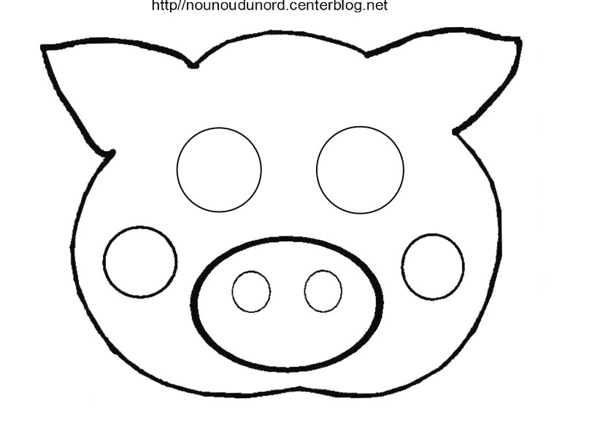

**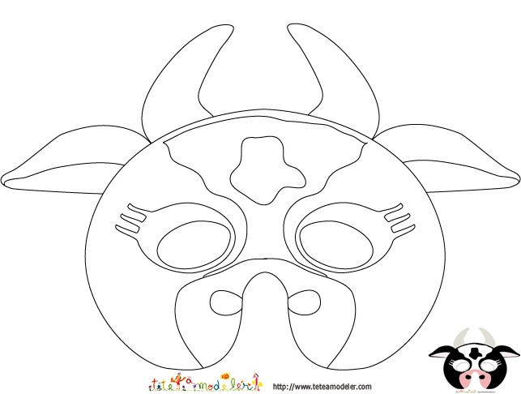**

**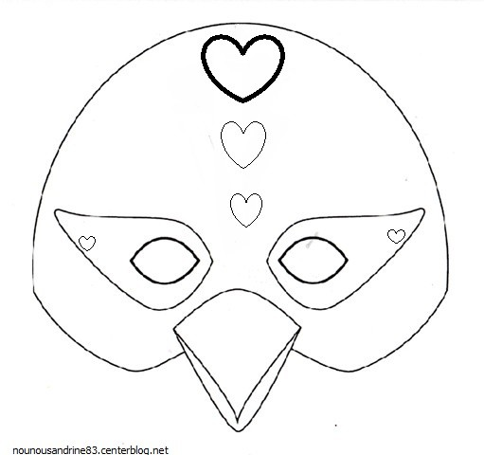**

**Annexe 2**

|  |  |  |
| --- | --- | --- |
| cochon.jpg | vache.jpg | poule.jpg |
| bacon.jpg | lait.jpg | oeufs_fond_blanc.jpg |
|  | hp1-steak.png | cuisse-de-poulet.jpg |
| cotelettes de porc.jpg |  | ailes poulet.jpg |

cochon : <https://www.quizz.biz/uploads/quizz/233006/2_ynigl.jpg>

vache : <http://www.larousse.fr/encyclopedie/data/images/1001183-Vache_de_la_race_Holstein-Friesian.jpg>

poule : <http://cdn.cuisinealafrancaise.com/img/thumbs/Poule_coq_chapon-621ff61accdfabf6daf883cfc766debb.jpg>

œufs : <https://www.lanutrition.fr/sites/default/files/styles/preview_article_standard/public/ressources/oeufs_fond_blanc.jpg?itok=NwFKNXn0>

lait : [https://www.google.ca/search?newwindow=1&safe=off&biw=1429&bih=750&tbm=isch&sa=1&q=lait&oq=lait&gs\_l=psy-ab.3..0i67k1l2j0l2.187070.188550.0.189006.4.4.0.0.0.0.168.529.0j4.4.0....0...1.1.64.psy-ab..0.4.525.az\_VjnejHI4#imgrc=WjM0jbqnjd9YxM](https://www.google.ca/search?newwindow=1&safe=off&biw=1429&bih=750&tbm=isch&sa=1&q=lait&oq=lait&gs_l=psy-ab.3..0i67k1l2j0l2.187070.188550.0.189006.4.4.0.0.0.0.168.529.0j4.4.0....0...1.1.64.psy-ab..0.4.525.az_VjnejHI4" \l "imgrc=WjM0jbqnjd9YxM):

steak : <https://az727346.vo.msecnd.net/content/images/hp1-steak.png>

bacon : <http://ghk.h-cdn.co/assets/16/08/980x490/landscape-1456165374-bacon-strips.jpg>

cuisse de poulet : <http://a136.idata.over-blog.com/283x300/3/96/83/96/Dossier-n-2/cuisse-de-poulet.jpg>

ailes de poulet : <http://www.vegifruits.ca/images/produits/iStock_000013993127XSmall.jpg>

côtelettes de porc : <http://assets.kraftfoods.com/recipe_images/rec_r1_42428v0fc.jpg>

**Annexe 3**

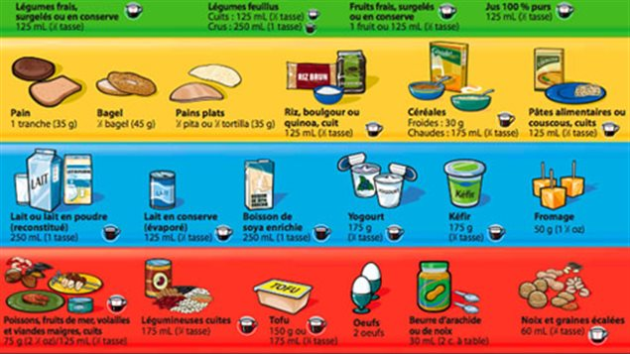

Source : <http://img.src.ca/2015/05/06/635x357/150506_vs891_rci-3_sn635.jpg>

**Annexe 4**

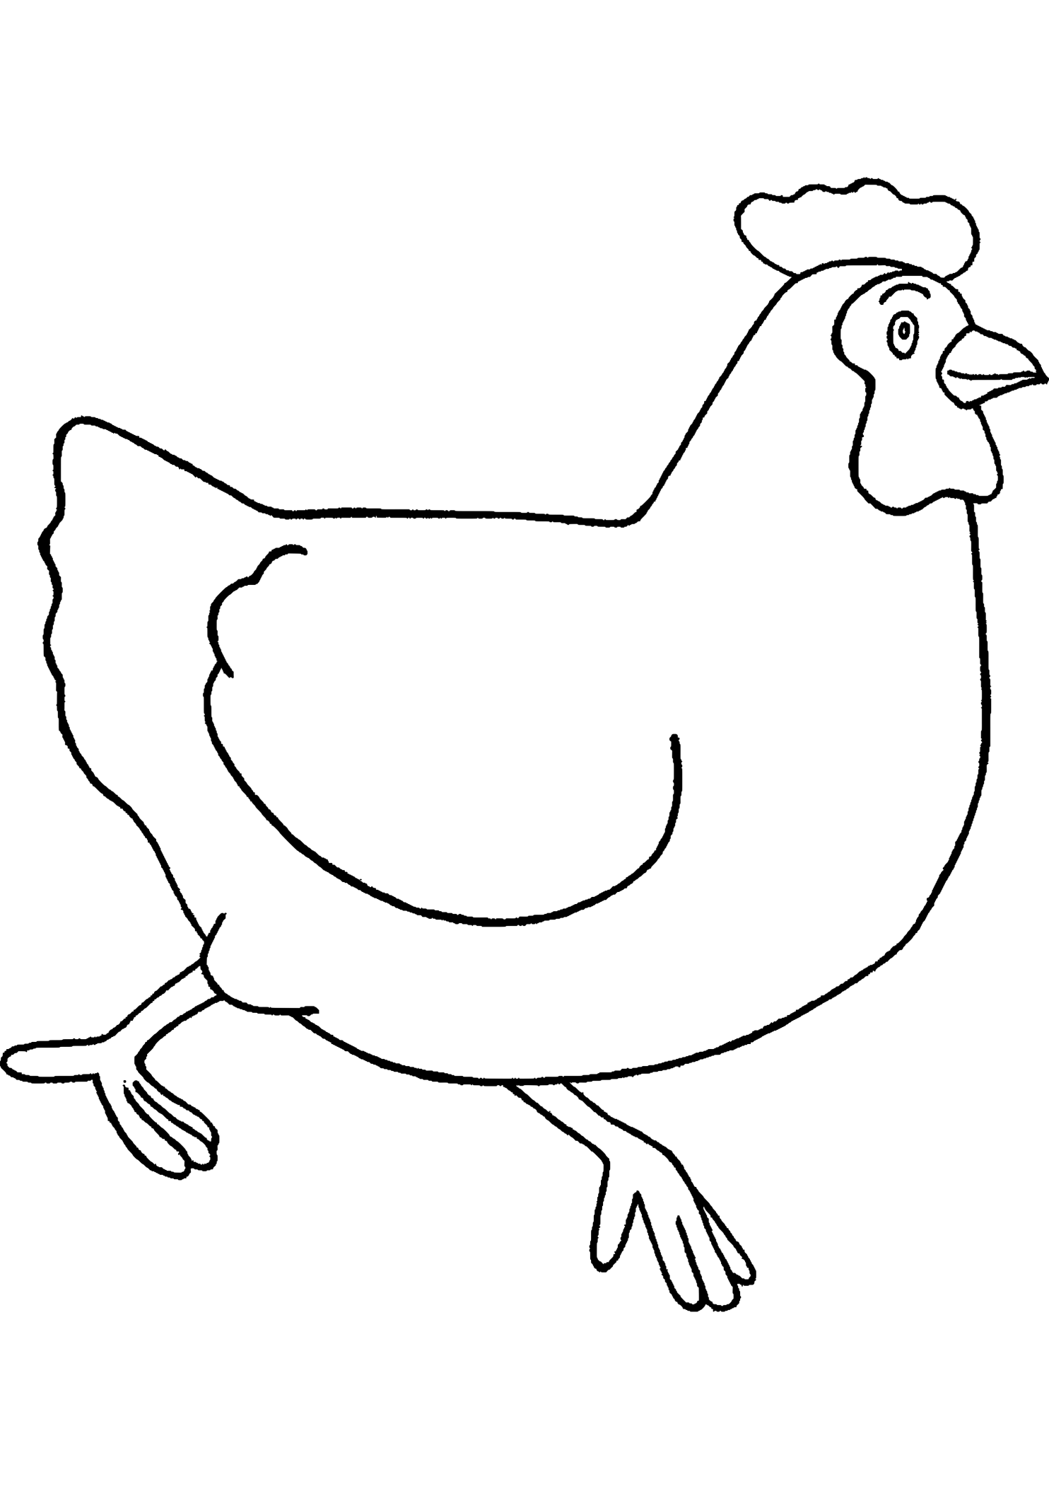

\_\_\_\_\_\_\_\_\_\_\_\_\_\_\_\_\_\_\_\_\_\_\_\_\_\_\_\_\_\_\_\_\_\_\_\_\_\_\_\_\_\_\_\_\_\_\_\_\_\_\_\_\_\_\_\_\_\_\_\_\_\_\_\_\_\_\_\_\_\_\_\_\_\_\_\_\_\_\_\_\_\_\_\_\_\_\_\_\_\_\_\_\_\_\_\_\_\_\_\_\_\_\_\_\_\_\_\_\_\_\_\_\_\_\_\_\_\_\_\_\_\_\_\_\_\_\_\_\_\_\_\_\_\_\_\_\_\_\_\_\_\_\_\_\_\_\_\_\_\_\_\_\_\_\_\_\_\_\_\_\_\_\_\_\_\_\_\_\_\_\_\_\_\_\_\_\_\_\_\_\_\_\_\_\_\_\_\_\_\_\_\_\_\_\_\_\_\_\_\_\_\_\_\_\_\_\_\_\_\_\_\_\_\_\_\_\_\_\_\_\_\_\_\_\_\_\_\_\_\_\_\_\_\_\_\_\_\_\_\_\_\_\_\_\_\_\_\_\_\_\_\_\_\_\_\_\_\_\_\_\_\_\_\_\_\_\_\_\_\_\_\_\_\_\_\_\_\_\_\_\_\_\_\_\_\_\_\_\_\_\_\_\_\_\_\_\_\_\_\_\_\_\_\_\_\_\_\_\_\_\_\_\_\_\_\_\_\_\_\_\_\_\_\_\_\_\_\_\_\_\_\_\_\_\_\_\_\_\_\_\_\_\_\_\_\_\_\_\_\_\_\_\_\_\_\_\_\_\_\_\_\_\_\_\_\_\_\_\_\_\_\_\_\_\_\_\_\_\_\_\_\_\_\_\_\_\_\_\_\_\_\_\_\_\_\_\_\_\_\_\_\_\_\_\_\_\_\_\_\_\_\_\_\_\_\_\_\_\_\_\_\_\_\_\_\_\_\_\_\_\_\_\_\_\_\_\_\_\_\_\_\_\_\_\_\_\_\_\_\_\_\_\_\_\_\_\_\_\_\_\_\_\_\_\_\_\_\_\_\_\_\_\_\_\_\_\_\_\_\_\_\_\_\_\_\_\_\_\_\_\_\_\_\_\_\_\_\_\_\_\_\_\_\_\_\_\_\_\_\_\_\_\_\_\_\_\_\_\_\_\_\_\_\_\_\_\_\_\_\_\_\_\_\_\_\_\_\_\_\_\_\_\_\_\_\_\_\_\_\_\_\_\_\_\_\_\_\_\_\_\_\_\_\_\_\_\_\_\_\_\_\_\_\_\_\_\_\_\_\_\_\_\_\_\_\_\_\_\_\_\_\_\_\_\_\_\_\_\_\_\_\_\_\_\_\_\_\_\_\_\_\_\_\_\_\_\_\_\_\_\_\_\_\_\_\_\_\_\_\_\_\_\_\_\_\_\_\_\_\_\_\_\_\_\_\_\_\_\_\_\_\_\_\_\_\_\_\_\_\_\_\_\_\_\_\_\_\_\_\_\_\_\_\_\_\_\_\_\_\_\_\_\_\_\_\_\_\_\_\_\_\_\_\_\_\_\_\_\_\_\_\_\_\_\_\_\_\_\_\_\_\_\_\_\_\_\_\_\_\_\_\_\_\_\_\_\_\_\_\_\_\_\_\_\_\_\_\_\_\_\_\_\_\_\_\_\_\_\_\_\_\_\_\_\_\_\_\_\_\_\_\_\_\_\_\_\_\_\_\_\_\_\_\_\_\_\_\_\_\_\_\_\_\_\_\_\_\_\_\_\_\_\_\_\_\_\_\_\_\_\_\_\_\_\_\_\_\_\_\_\_\_\_\_\_\_\_

Source : <https://www.dessin-colorier.com/img/coloriage-de-poulet-1-2975x4200-2246.png>