

**greenchurches.ca**

**Fair Trade**

Serving justice on your plate

|  |  |
| --- | --- |
| **Objective** | This activity is part of the educational serie. At the end of this activity, the Christian community will have a better understanding of the importance of fair trade. Thus, it will promote the participant to buy more fair trade certified products. |
| **Length** | An hour and a half : 15 minutes for the introduction/welcome word, 5 minutes needed to get to the projection site, 60 minutes for the activites by age group, 10 minutes to get feedback on the activity |
| **Needed items** | **Everyone :** two pieces of chocolate by person (one piece fair trade and one normal), the necessary items for the video projection ( laptop, speakers, projector, videos: downloaded or online )  **3 to 6 year old :**  *<http://schools.fairtrade.org.uk/resource/pablo-the-super-banana/>*  **Video :** *Pablo the Super Banana* (Fair trade UK)  **Needed accessories :** plastic fruits, plastic grocery basket, a toy cash register, reusable grocery bags, an apple, a banaba, globe, a copy of appendix 1 by child (the annex about fruits and vegetables), the big fair trade logo (appendix 2), magnifiers, fair trade logos (need to cut and plastify logos from appendix 3), scotch tape, colour pencils , children scissors, glue stick, cardboards with fair trade logo and Jesus (appendix 2 et 4), various toys for free game play. 7-12 years old :*<https://www.youtube.com/watch?v=qFOmeWY1zUM>*Video: Once upon a time... Planet Earth - Child Labour, Child Soldiers Laptop, projector, speakers (you can take the one from the younger *Pablo the Super Banana* projection), bibles, fair trade logo (appendix 2), copy of the pledge (appendix 6), pencils and erasers, scissors, glue sticks, card board with images from appendix 5.  Teenagers : Find someone in order to get a testimony  Adults : Find a speaker. If not possible : bibles will be needed and the « road of coffee » page (appendix 8). |
| **Suggested locations** | Church for the gathering and available community halls for the different activities by age group. Prioritize outodoor activities if weather is nice. |
|  |  |

**Welcoming and introduction (15 minutes)**

Upon arrival time, each participant receives 2 pieces of chocolate. One fair trade and one ‘regular’.

The organizer asks the participants to notice de differences (taste, odor, apperances) between the two pieces of chocolate.

After listening to a few answers, the participant should tell which one was free trade market while the other was not.

What is free trade? Today, we’ll discover what is all about!

As an introduction and trigger (kick start) for discussion and activities, watch the video called Under-Appreciated produced by Fair Trade UK : <http://schools.fairtrade.org.uk/resource/under-appreciated/>

Take time to mentioned all the different products that can be concerned by Free Trade: coffee, sugar, rice, bananas, etc. There is a great diversity of fair trade products. We usually think only of food when when we are thinking of fair trade products but even footballs can be part of the fair trade: <http://schools.fairtrade.org.uk/resource/football/>

Today, in each age group, we’ll learn how to become more fair and better consumers…

**Time required to shift to the activity (5 minutes)**

Depending on the age group, make sure the participants know where they need to go for the group presentation/activity. Present all volunteers taking care of the youth. Make sure everyone goes to the right location.

**Activity by age group (60 minutes)**

6 year old and younger

The goal for the childrend age 6 year old and younger is to understand where the food is coming from. What is the geographical origin of food ?

1. Do the groceries (game)

Invite the children to do like if they were buying groceries. Prepare platic fruits, plastic grocery basket, toy cash registrer, reusable grocery bags, etc. If you don’t have any plastic food item it is possible to print some for the appendix pages.

2. Food has an origin

Tell the children to sit in a circle. Ask each child to empty their grocery bag. The person doing the presentation takes an apple and asks the children where it’s coming from. Please insist on the fact that apples are growing in this province. Ask them if they ever been apple picking during fall. Explain that it’s local food in this region, you can pick them from tree in apple orchards. Take a banana and ask the participants where it comes from? Where does it usually grow? You could tell them that it comes from many places : India, China, Philippines, Brazil, Equador, Indonesia, etc. It would be interesting to show the different countries on a globe.

Present the different fruits and vegetables from the included page (appendix 1). Tell them that they’re all fruits and vegetables we can buy fair trade certified. It means the farmers received a fair salary as a result of their efforts. It means they received a salary that allows them to live well. Enough money for food, clothes, housing. Tell them that to know if a product is fair trade you must find the special picture (logo) on the packaging. Show the fair trade logo to all participants (appendix 2).

3. The Detective Game

Tell the children thaet we’re now going to play the Detective Game. They must find all the hidden food items in the room where they can identify the fair trade logo. The organizers can even give a few magnifier glasses, making it more realistic for the children that they are detectives of the ‘fair trade’ world.

Suggestion : During step 2 (Food has an origin), take the plastic food items and tape the fair trade logo on them (see appendix 3). While the children are carefully listening to the person presenting the other volunteers could hide the food in the room.

Conclude the activity by saying that they could play the Detective Game when they are buying the groceries with their parents.

4. Collective craft

Ask the children if they think fair trade is making Jesus happy. With fair trade, farmers are receiving a salary that allows them to live well – we are pretty sure Jesus loves it when people are getting some respect for their hard work.

Ask the children to color the fruits and vegetables they like the most (see appendix 1) . They then need to cut them and glue them on the cardboard where the free trade logo is (appendix 2) and Jesus smiles (appendix 4).

5. Free play

7 to12 year old

1. Watch this video :

# [*https://www.youtube.com/watch?v=qFOmeWY1zUM*](https://www.youtube.com/watch?v=qFOmeWY1zUM)

# Video: Once upon a time... Planet Earth - Child Labour, Child Soldiers

2. Listen to the reactions of the children when done

3. Discussion

Have a discussion on the children labour presented in the *Once upon a time* video.

Are children made to work? Aren’t they supposed to go to school?

Does the children have good work conditions?

(In the video, the employer is rude in the way he looks at children. He’s aggressive and sabotage the work of the boy.

From your perspective, do you think free trade brings something positive to the problem of child labour ? ( If the parents can own a more decent salary, they’re not forced anymore to send their kids work on the field. The cooperative has the money to build a local school, etc.)

4. Biblical text

In some countries, children exploitation is related to some kind of slavery. Do you think God loves that? Is there a text in the Bible when we know more about God’s reaction to the slavery of his beloved children ?

Read Exodus 3 :7-10 with the young people

7Then the Lord said, “I have observed the misery of my people who are in Egypt; I have heard their cry on account of their taskmasters. Indeed, I know their sufferings, 8and I have come down to deliver them from the Egyptians, and to bring them up out of that land to a good and broad land, a land flowing with milk and honey, to the country of the Canaanites, the Hittites, the Amorites, the Perizzites, the Hivites, and the Jebusites. 9The cry of the Israelites has now come to me; I have also seen how the Egyptians oppress them. 10So come, I will send you to Pharaoh to bring my people, the Israelites, out of Egypt.”

How are the sons of Israels treated by the Egyptians?

Back then, and now - God wants good work conditions for everyone.

5. Collective work

What can we do to help children who are forced to work? (buy fair trade products..)

Show the fair trade logo to everyone (appendix 2).

Ask the youth to write down on a piece of paper (appendix 6), what are they gonna do to become more responsible free trade consumers? It’s possible to initiate a brainstorm with them. Once they have written down what they want to commit to they need to cut it and glue it on the cardboard. The cardboard has an image of the slave Hebrews and has a picture of a child cutting a cacao fruit. (see appendix 5).

6. To go further …

Sign a petition against child labor.

You could send, print or present the story of the Brazil nut ( to download the Powerpoint presentation. First button on the right : The Story of the Brazil nut )

<http://schools.fairtrade.org.uk/resource/story-brazil-nut/>

Tennagers

For the teenagers group, the prefered way to promote environmental awareness would be to have a testimony from someone. It is a good way to reach this age group. It could be interesting to ask a missionary or a young adult who have experience in international cooperation. There is nothing like a young person who tries to convince another young person. The goal with teenagers is to bring awareness of the difficult work conditions of workers in the South in order to promote fair trade.

If you don’t know anyone that could come for a testimony in your christian community, an alternative would be to ask them them the same questions as the adults on the *Under-appreciated* video.

Adults

*Suggestion*

It would be nice to offer coffee to the participants. Must be fair trade! On the wall you can put the poster on the appendix 7 page.

For adults, it would be interesting to invite someone representing international cooperation organization such as *Oxfam* or *Development and Peace*. The fair trade topic could be explained further. It would be interesting to keep some time for questions and discussion between participants in order for them to integrate what has been learned.

If it’s not possible to find a speaker, here a suggestions of questions that you might want ask after watching the Under-Appreciated video. Sharing would need to be done in small groups.

What will I remember from this video? What am I learning from the video? Which questions am I asking myself? Which emotions this video brings me?

- At the end of the video, this is what should be told : “if all of us would realize that behind a simple chocolate bar human beings can be exploited, we would probably make better consumer choices and prefer a fair trade chocolate, even though it’s a bit more expensive. We would prefer a product that respects human and environmental rights. What do you think?”

Biblical sharing time - Ezekiel 34, 1:-4 (*Israel’s False Shepherds*)

34 The word of the Lord came to me: 2Mortal, prophesy against the shepherds of Israel: prophesy, and say to them—to the shepherds: Thus says the Lord God: Ah, you shepherds of Israel who have been feeding yourselves! Should not shepherds feed the sheep? 3You eat the fat, you clothe yourselves with the wool, you slaughter the fatlings; but you do not feed the sheep. 4You have not strengthened the weak, you have not healed the sick, you have not bound up the injured, you have not brought back the strayed, you have not sought the lost, but with force and harshness you have ruled them.

Something to think about : We can draw a parallel between good and bad shepherds and the big multinational corportations selling coffee and chocolate. Just like bad shepherds who are not taking good care of their flock, big multinational corporations abuse and exploit small producers.

- At the end of this activity on fair trade, am I inspired to buy (or buy more) fair trade products? Which ones and why?

On the appendix 8 we can find two images, the traditional coffee route and the fair trade one. You can use these pages to feed the discussion

**Feedback on the activity (10 min)**

For the youth groups (6 year old and less / 7 to 12 year old) a youngster or volunteer can show and present the collective work realized by the youth groups. A teenager is then invited to share what he finds important from the testimony given. An adult can then summarize the fruits beared from the sharing time

End with a prayer.

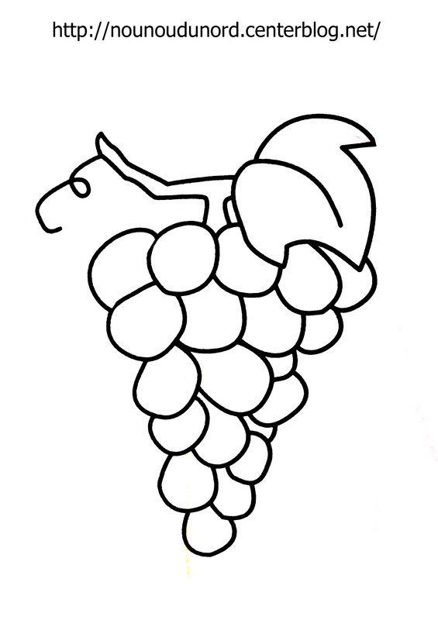**Appendix 1**

Annexe





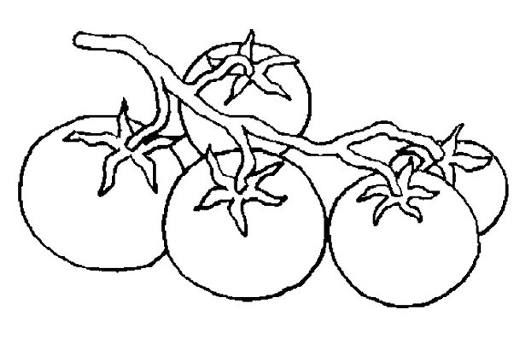



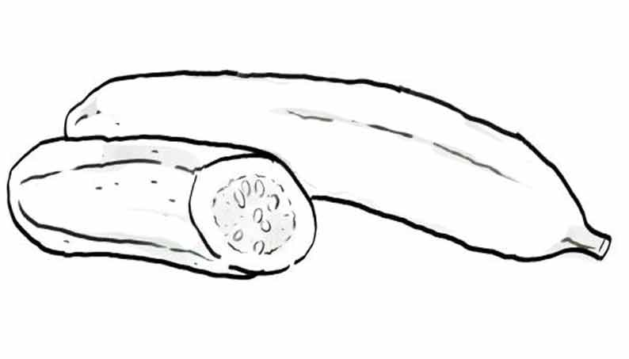

**Appendix 2**



**Appendix 3**

|  |  |  |  |
| --- | --- | --- | --- |
| **fairTradeLogo.gif** | **fairTradeLogo.gif** | **fairTradeLogo.gif** | **fairTradeLogo.gif** |
| **fairTradeLogo.gif** | **fairTradeLogo.gif** | **fairTradeLogo.gif** | **fairTradeLogo.gif** |
| **fairTradeLogo.gif** | **fairTradeLogo.gif** | **fairTradeLogo.gif** | **fairTradeLogo.gif** |
| **fairTradeLogo.gif** | **fairTradeLogo.gif** | **fairTradeLogo.gif** | **fairTradeLogo.gif** |
| **fairTradeLogo.gif** | **fairTradeLogo.gif** | **fairTradeLogo.gif** | **fairTradeLogo.gif** |
| **fairTradeLogo.gif** | **fairTradeLogo.gif** | **fairTradeLogo.gif** | **fairTradeLogo.gif** |

**Appendix 4**

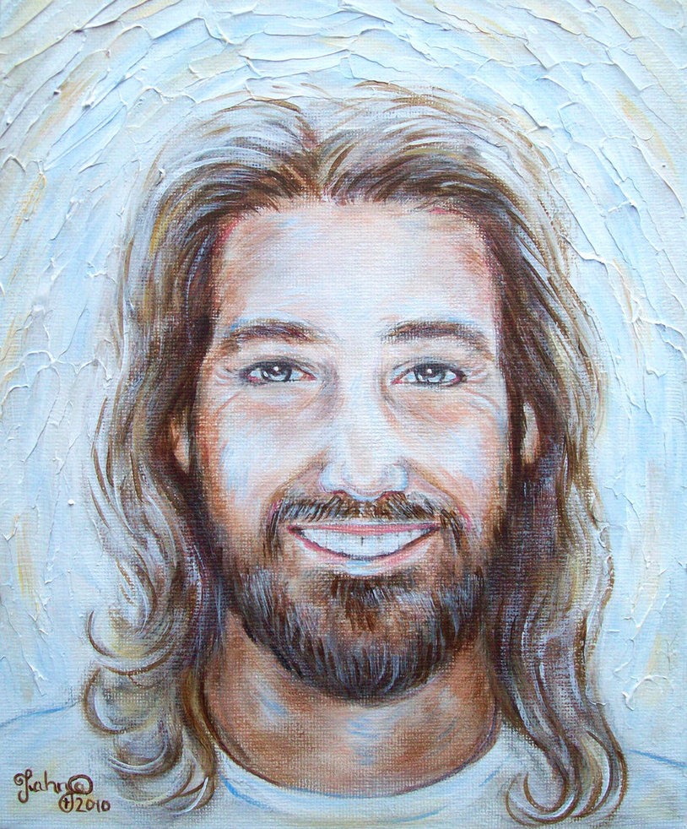

Source : Tanja 2010

**Appendix 5**

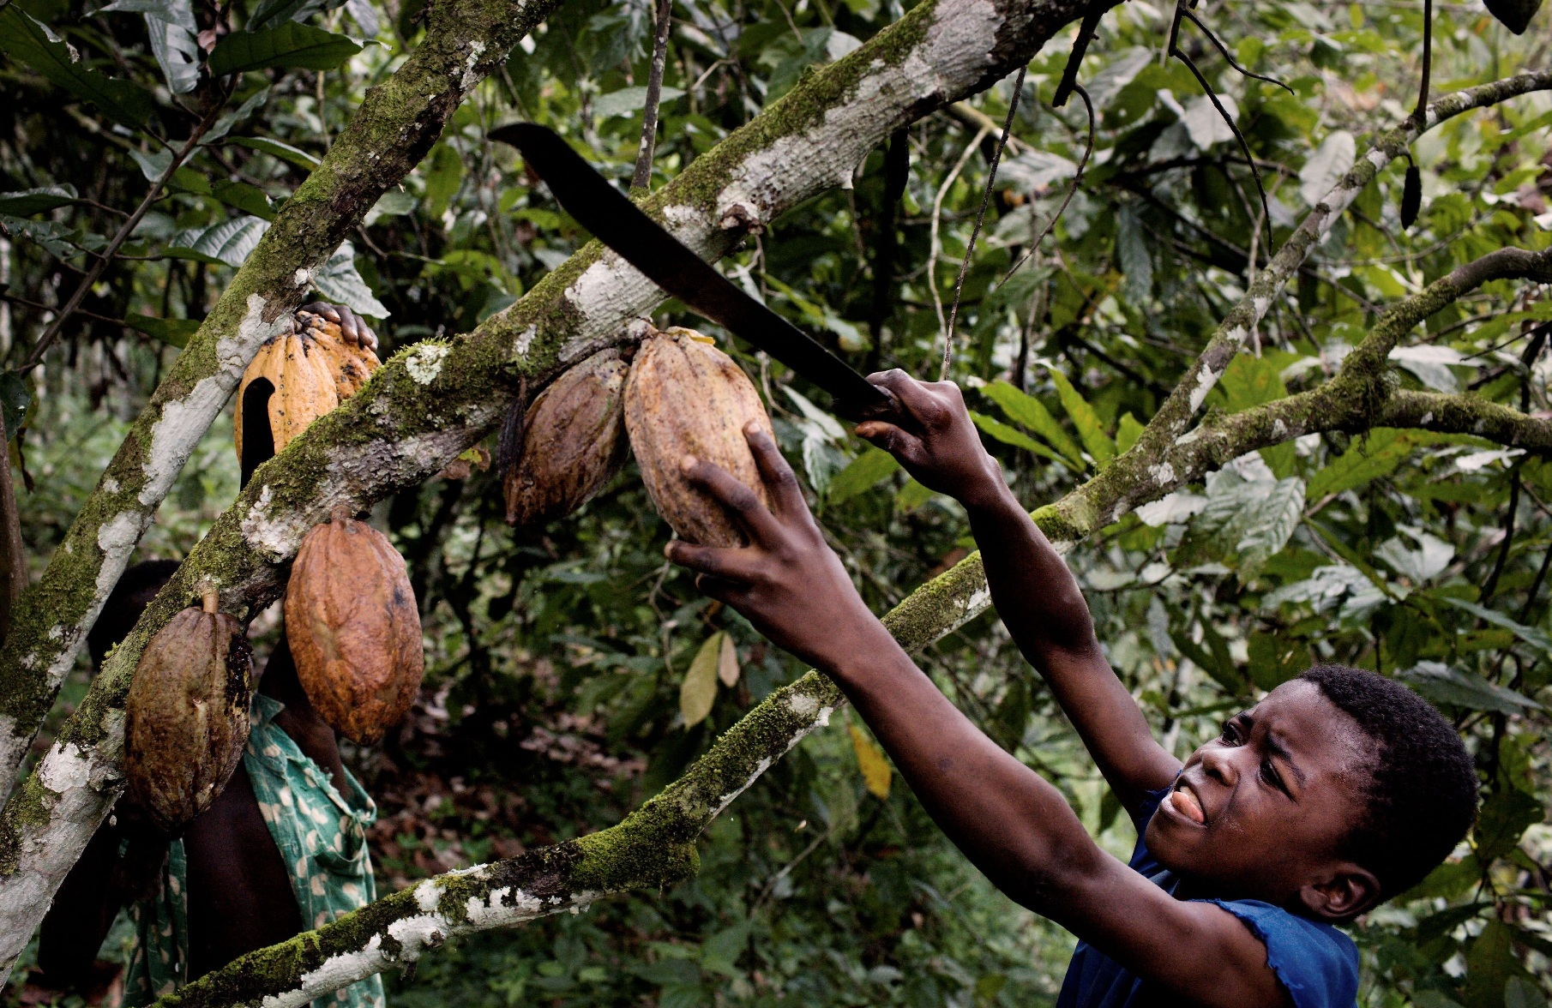

Source photo : sfentona

**Hebrews as slaves in Egypt**

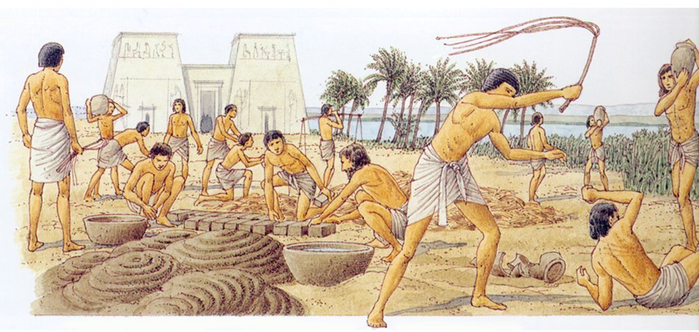

Source : thorapourenfant.blogspot.com

**Appendix 6**

**Today I’m commiting myself to :**

_________________________________________________________________________________________________________

_________________________________________________________________________________________________________

_________________________________________________________________________________________________________

_________________________________________________________________________________________________________

______________________________________________________________________________________________________________________________________________________________________________________________________________________________________________________________________________________________________________________________

**Today I’m commiting myself to :**

_________________________________________________________________________________________________________

_________________________________________________________________________________________________________

_________________________________________________________________________________________________________

_________________________________________________________________________________________________________

______________________________________________________________________________________________________________________________________________________________________________________________________________________________________________________________________________________________________________________________

**Today I’m commiting myself to :**

_________________________________________________________________________________________________________

_________________________________________________________________________________________________________

_________________________________________________________________________________________________________

_________________________________________________________________________________________________________

______________________________________________________________________________________________________________________________________________________________________________________________________________________________________________________________________________________________________________________________

**Appendix 7**

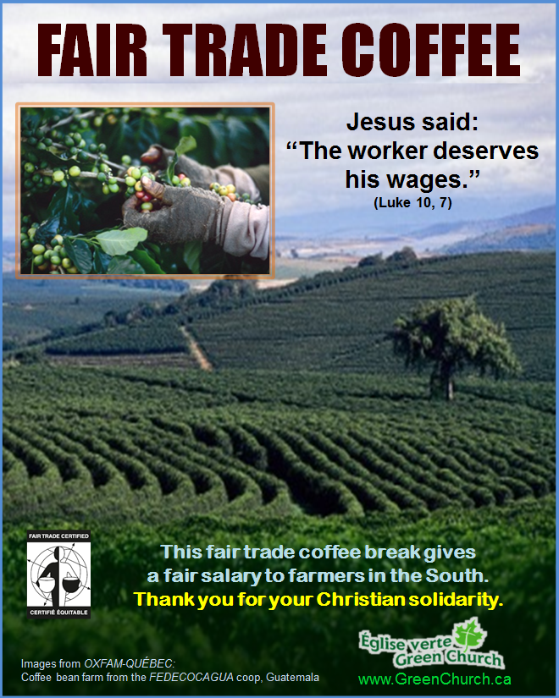

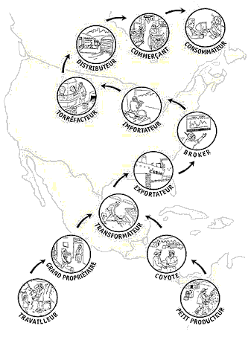**Appendix 8**

Le chemin traditionnel du café

Le chemin équitable du café

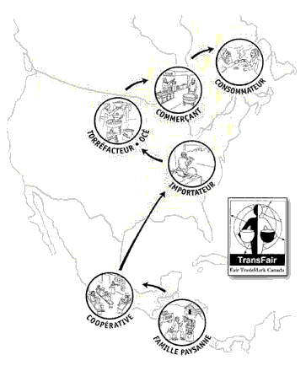

© Caroline Langis, 2006